CANOBIE CONNECTION

John Glendinning, my Great Grandfather settled in the Bathurst area about 1830; later he moved to Canobie where my father, Elmer Glendenning was born. This chapter deals with the Canobie connection to the Glendenning family.

Early Names

Travelling east from Bathurst along the coast towards Caraquet, one finds a number of communities familiar to the Glendenning family. The following information was taken from Geographical Names of New Brunswick, 1875.

Bathurst, originally named St. Peters in 1671, was named for the Third Earl of Bathurst in 1826.

Salmon Beach was settled around 1820 by immigrants from Ireland and included the districts of Prospect Hill, Strawberry Plain and Mount Pleasant.
Janeville was named for Jane Dawson, wife of Benjamin Dawson who settled there about 1835.
Stonehaven was probably named for Stonehaven, Scotland.
New Bandon was settled in 1819 by several families from Bandon, Ireland.

If one turns inland along the Janeville Road one comes to Canobie which was named
after Canonbie, Dumfriesshire, Scotland.

According to Pioneer Settlers of the Bay Chaleur. Settlement on the coast east of Bathurst took place by the Acadians in the latter half of the 1700s and, although living on the land, their grants were not given until 1812. The first registered land grant was to James Sutherland and his brother Hugh, and Richard Nevison in 1789. Apparently, an organized system of granting of land did not evolve until the 1800s and even then there could be delays of a decade or more between petitioning for land and receiving it. Even then, the grant was not final until at least five acres had been cleared.

Once settled, men began the task of clearing land and erecting a dwelling and barn. Trees not needed were stacked, dried and burned. Few oxen or horses were available so the land was broken and cultivated with the aid of a hoe. The initial crops were planted between the stumps, which, over time, rotted and were removed. In many cases, the initial seeds came with the settler from the old country.

Immigrants came by boat to Bathurst, Pokeshaw, Bass River and Caraquet. Others came to Saint John, Miramichi or even Halifax and changed ships or even walked through to the Bathurst area. (Maryanne Harley, as reported earlier, landed in Pokeshaw and walked through to Newcastle where her brother was living at the time.) One might wonder why immigrants landed at Pokeshaw. The Bay Chaleur history records that Pokeshaw had a secure harbour, was an active fishing centre. As early as 1812, 30 acres of land had been cleared and had a number of houses constructed. Sailing vessels stopped there for water and supplies including fresh meat.

John Glendinning

Into Salmon Beach on or about 1830 came John Glendinning. We do not know exactly when he arrived or how he got there. Around the same time period, there were a number of Glendennings who arrived from the Dumfries area of Scotland and settled in the Saint John area; some moved later to Nova Scotia. According to Pioneer Settlers, John Glendinning, Sr. is believed to have purchased part of Lot No. 7 at Salmon Beach from Fidele and Joseph Arceneau

John and Margaret (Harley) Glendinning (Great-grandparents)

John Glendinning, my great-grandfather, was born on April 2, 1807, at Callister Hall, Parish of Middlebie, Dumfriesshire, Scotland. He was baptized on July 10, 1808

In 1830, he sailed from Annan, a seaport on the south coast of Scotland. This would be the nearest port to where he was born. It is likely, although we have no record that he landed at Pokeshaw on the Bay Chaleur near Bathurst, New Brunswick, as Pokeshaw was a busy seaport and sailing ships seemed to be a regular stop from overseas. According to Pioneer Settlers of the Bay Chaleur, he purchased part of Lot 7 at Salmon Beach which was between Pokeshaw and Bathurst. On August 23, 1833, he married Margaret Harley who had come from Ireland to New Brunswick to join other family members.

Margaret Glendinning was a schoolteacher and the first school in Salmon Beach was opened in her home in 1838. By 1842 a new school was opened at Upper Salmon Beach. The school measure 12 feet by 12 feet by 6 feet and housed 27 pupils. School reports of the time (1842, I believe) reported that:

- her original license was issued in 1838
- her first school was in her own home; later she taught in the new school erected before 1842
- summer attendance averaged 27; winter attendance averaged 22
- instruction emphasized reading, writing and arithmetic
- Margaret listed herself as Church of England
- She taught school for at least six years
- the new school measured 12 ft. By 12 ft. By 6 ft.
- furniture consisted of a small table and benches
- girls were taught sewing

According to the Bay Chaleur history, settlers raised sheep, carded and spun wool and wove cloth. John Glendinning, presumably the Senior John, owned one of the first weaving machines in Canobie and taught others in the community to weave. I recall my mother saying that Grandmother Glendenning possessed a shuttle. Apparently, the shuttle passed to Aunt Venetia Doring and from her to Cornelia Farrell.

According to Pioneer Settlers, John and Margaret sold their land in 1855 to Abram Buttimer and moved inland to Canobie. We do not know the reason for moving but we do know that waterfront land at Salmon Beach took a heavy beating and some flooding from storms. Also with a growing family and cheap land he may have felt that he would give his family a better start in Canobie.

Land Grants

The map below gives the location of many of the original land grants in Canobie; most, if not all, about 100 acres each.

36 Norman Peters 1892-03-07
35 F.W Ellis 1939-10-06
34 John Jagoe 1872-12-30
33 J. McCarthy 1882-08-12
32 J. McCarthy Jr 1868-04-29
31 J Glendenning 1868-08-17
30 Walter Glendenning 1873-02-17
29 H. Knowles 1886-02-23
28 E. Glendenning 1901-07-16
27 Timothy Savage 1874-04-20
26 John W. Lowe 1872-07-29
25 John Taylor 1873-06-27
24 Julian Landry 1904-02-26
23 R. H. Sealey 1929-11-29
22 Thomas. A. Knowles 1926-10-25

The maps show Walter and John Glendenning, however, another government documents show Glendinning. Directly across the road from the Glendenning property, we have:

15 Abraham Jagoe 1869-09-26
14 Silvanus Ellis 1890-11-25
13 Edward Cormier 1899-08-31

In Springfield Settlement, which was settled much later we find:

7 Richard S. Glendenning 1942-05-27
6 Guy E. Glendenning 1946-06-21
5 Gordon Glendenning 1946-10-30

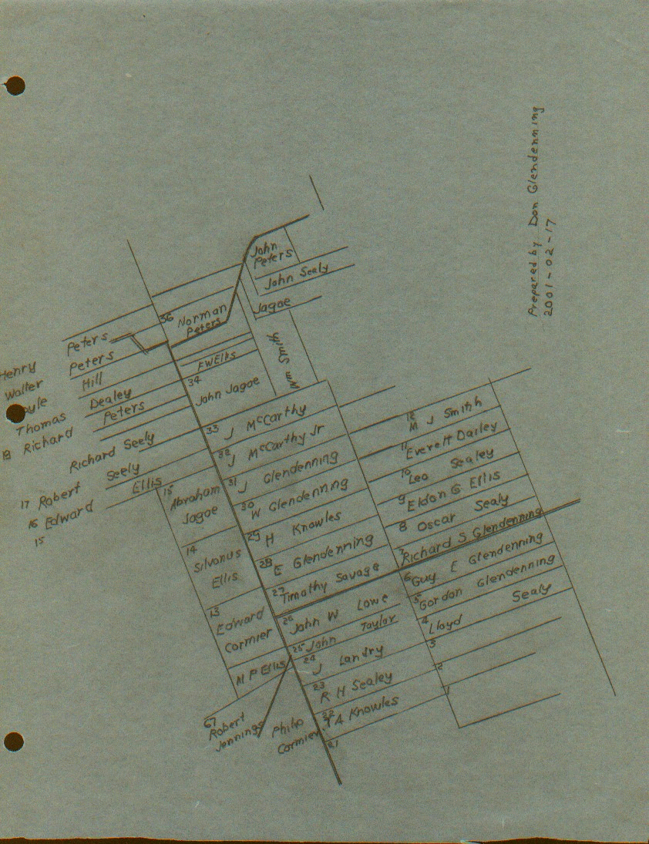

Early Land Grants in Canobie

It appears that John Glendinning petitioned for both Lots 30 and 31. When the grants were made, however, they were in the names of his sons, John and Walter. He and his family may have been living on the lot since it was not unusual for early settlers to live on land for a number of years before receiving title; they may have even been required to clear a number of acres and even build a house.

Lot # 28, 100 acres, was granted to Atton E. Glendenning on 1901-07-06. Would this be, Dad, Alton E. Glendenning?

Census of 1861 shows household of John Glendinon:

John, Aged 54,Scotch, Farmer, Presbyterian
Margaret, Wife, Aged 54, Irish, Church of England
Elizabeth, Aged 16
Walter, Aged 15
John, Aged 21

The 1871 census shows:
Walter Glendenning Aged 25
John Glendenning, Father, aged 64
Margaret Glendenning (wife) aged 70

Children of John and Margaret (Harley) Glendenning include:

Mary Anne
John
Margaret
Elizabeth Jain
Walter

John Glendinning, Sr. died May 15th 1877 in Canobie; his wife, Margaret (Harley) Glendenning died on October 21, 1895. I do not have any record of where they are buried.

John, Jr. and Ellen (Dickey) Glendinning

John, Jr. Married Dickey and between 1869 and 1879 when Ellen died. During that time, Walter, his brother purchased the adjacent lot, married and was raising a family. I believe that John=s children were practically raised by Walter and his family. Millicent, for example, was like a sister to Elmer rather than a brother. John and Ellen are buried in the New Bandon Cemetery.

I am told that, in 1873, John and Ellen Glendenning sold 1/4 acre of land for a school on the opposite side of the road from the current school. The property across from the Glendinning property was granted to Abram Jagoe on September 26, 1861. I also read that the school was built in 1872.

A headstone, tapered red granite, in the New Bandon Cemetery, according to the Gloucester Cemetery Inscriptions, read as follows:

John, July 18, 1880, Age 52
Wife Ellen Dickey, May 16, 1879, Age 33
Child Ellen A, June 1, 1879
William J
April 12, 1897 Age 23

Walter and Elizabeth (Peters) Glendenning (Grandparents)

Walter Glendenning was born on 26 November 1845.

The property is directly across from the Canobie School, which is now the Women’s Institute Hall. The old home stood, among what is now a clump of trees. I believe that the homestead was inherited by his son, Leonard.

Walter was active in the church including being a Sunday School teacher. At first, church services were held in the local school. Later Trinity Union Church was erected in 1899 about a mile from the Glendinning property and was used by Presbyterians, Methodists and Anglicans. (It is now an Anglican Church). Walter is reported to have been one of the first trustees and, according to the Chaleur history, cut the first lumber to start the building. It s a small church with 8-10 pews on each side. The names of Mr. and Mrs. Walter Glendenning are included on a plaque in memory of the early church families. (Mr. and Mrs. John Glendenning’s names are also included)

Walter lived in Canobie and was active in community affairs. In 1882 he was one of the people responsible for turnpiking a new road into the Springfield Settlement. He was also a successful farmer.

Elizabeth Peters, born in Canobie, was the daughter of John Peters (October 23, 1821 - June 31, 1904) and Jane (Sealy) Peters (December 24, 1821 - September 12, 1892). According to a note in some family records, John Peters and Jane Sealy were married in October of 1847 and lived all their lives in Canobie, New Brunswick.

Walter carried on mixed farming and would, I believe, have been considered a successful farmer in his day. At his death, he owned:

- Lot No. 30, Canobie, the old homestead, formerly surveyed for Charles Scott. By him transferred to John Glendinning and from John Glendinning to his son Walter the present applicant.

- 100 acres in Canobie, which I believe to be Lot #28, which he left to his wife, Elizabeth. It appears that Dad bought this land originally and then sold (?) it to his father. This may have been the lot on which Uncle Chip lived.

- the Stevens Farm in Canobie containing 100 acres which he left to his wife, Elizabeth, with the proviso that it be transferred to his son Raymond if he returned to settle in Canobie.

- 50 acres, the original Taylor Farm, which he left to his wife Elizabeth. This property is immediately west of and adjoins the Stevens farm. Apparently this land was left to or purchased by his daughter. Venetia. Guy Glendenning said that Venetia sold the property to Matt. Ellis

In addition to having a fine large family, according to his will, he owned:

o a house
o 2 horses and a colt
o 9 cows
o 4 sheep
o 1 bull
o 4 heifer calf
o threshing mill
o binder
o seeder
o crusher
o wood cutter
o truck waggon
o express wagon
o buggy
o light open waggon
o mowing machine
o rake
o plow
o harrow
o bob sleds
o long sled
o run about
o one cart
o sewing machine

This would have been considered a well-equipped turn-of-the-century farm.

Walter Glendenning developed pneumonia and died while visiting his daughter, Venetia Doring (and other family members) who was living in Falmouth Foreside near Portland Maine at the time. His sons Elmer, Chipman, Ray, and Frank who ran a woods operation in New Hampshire. His will was written on January 6, 1908 just five weeks before he died. After his death, his wife, Elizabeth, went to live with her daughter Venetia in Falmouth, Foreside, Maine. She died there on May 14, 1915. Both are buried in the Presbyterian cemetery in New Bandon. NB (John and Ellen are also buried in that Cemetery. The cemetery is still maintained although the church has long since disappeared.

A headstone in the Cemetery (a black square stone) according to Cemetery of Gloucester County reads as follows:

Walter 1845- 1908
His wife, Elizabeth P. May 14, 1915 Age 67
Child Lillian 1870 - 1894
Rufus 1896-1898
Betty 1925-1928
Chipman L 1887-1948
His wife, Louise Ellis 1894-1966

FWH

In the Bell Holdings at Mount Allison University, I found Boyhood Memories of New Brunswick, written by FWH about 1940. It is a typewritten manuscript rather than a book and is about his boyhood memories in Canobie. Among other things, he mentions:

- an Uncle who was a Stevens and another who was a Knowles.
- he was born in Clifton, near the stone quarry.
- his grandparents lived in Newcastle during the Miramichi Fire (1825)
- Tim Savage, a near neighbour. (Lot # 27 in Canobie was owned by Tim Savage.)
- his mother was a schoolteacher who received $200 from the government and $200 from the district.

He also tells a ghost story based at a camp in the woods just south of Bathurst on the Red Pine Section of the Intercolonial Railroad. From what he said, his mother was at that camp. He ends his manuscript with his departure from Bathurst for Maine.

It is likely that he was a Henry, grandson of Mary Anne Harley and John Henry. I do not have the names of many of her family but understand that her husband, John, died in 1870 and she moved to Portland shortly thereafter. My records also show that one of Mary Anne’s daughters married a Knowles and another married a Stevens

